Edu Genie
Google Gemini Powered Learning Assistant
Project Documentation – System Design & Implementation

Project Name | Edu Genie – AI-Powered Multimodal Educational Assistant
Technology | Flask (Python) + Google Gemini API
AI Model | gemini-1.5-flash (auto-detected)
Backend | Flask REST API + Waitress WSGI
Frontend | HTML, CSS, JavaScript (Jinja2)
File Support | PDF, DOCX, PPTX, PNG, JPG, WEBP, HEIC
Document Version | 2.0 – With Architecture & Screenshots

Internship Project • 2026

1. SYSTEM OVERVIEW

EduGenie is a Flask-based web application that integrates the Google Gemini Generative AI API to provide intelligent educational support. The system is designed to assist students and learners through automated AI-driven features accessible via a simple web interface.

- AI-based question answering with multilingual support
- Automatic quiz generation (5 MCQs) in structured JSON format
- Document summarization from uploaded files
- Real-time streaming chat using Server-Sent Events (SSE)
- Multimodal input handling (text, PDF, DOCX, PPTX, images)

2. PROBLEM DOMAIN

- Large volumes of study material in multiple formats (PDFs, Word, PowerPoint, images)
- Manual preparation of quizzes and summaries is time-consuming and inefficient
- Students need instant clarification without manual searching
- Teachers spend excessive time creating assessment content

EduGenie addresses these problems by providing an intelligent, automated system that processes academic content and generates meaningful responses, summaries, and quizzes — reducing manual effort and improving learning efficiency.

3. CORE TECHNOLOGY STACK

Backend Framework | Flask (Python Web Framework)
Programming Language | Python 3.10+
AI Service | Google Gemini API (google-genai library)
AI Model | gemini-1.5-flash (auto-detected with fallback)
Frontend | HTML, CSS, JavaScript (Jinja2 Templates)
File Processing | PyPDF2, python-docx, python-pptx, Pillow
Configuration | python-dotenv (.env file)
Production Server | Waitress (WSGI)

4. SYSTEM ARCHITECTURE

4.1 High-Level Architecture Diagram
The following diagram illustrates the complete layered architecture of EduGenie, from the user's browser through the Flask backend to the Google Gemini AI service and deployment infrastructure:

FRONTEND LAYER
HTML Templates (Jinja2) • JavaScript (Fetch API) • CSS Styling
↓ HTTP Request | ↓ File Upload | ↓ SSE /chat
FLASK BACKEND (app.py)
/ask • /quiz • /summary • /chat • /models • /health
↓ Text Extraction | ↓ Prompt Build | ↓ API Call
FILE PROCESSOR  PyPDF2 / python-docx python-pptx / Pillow | PROMPT ENGINE  Construct context- aware prompts | GEMINI API CLIENT  google-genai gemini-1.5-flash
 | ↓ AI Response
GOOGLE GEMINI GENERATIVE AI API
Text Generation • Summarization • Quiz Creation • Multilingual Support
 | ↓ JSON Response to User
DEPLOYMENT: Waitress WSGI Server
Render • Railway • AWS EC2 • Google Cloud • Heroku
Fig. 1 – EduGenie High-Level System Architecture

4.2 Architecture Description
EduGenie follows a 3-tier client-server architecture:

- Presentation Layer (Frontend): HTML/Jinja2 templates with JavaScript Fetch API for asynchronous communication. The UI provides five feature tabs: Ask a Question, Explain, Summarize, Quiz Me, and Chat.
- Application Layer (Flask Backend): The core REST API built with Flask handles routing, input validation, file text extraction, prompt construction, and Gemini API communication across 8 endpoints.
- Service Layer (Google Gemini AI): The external Google Gemini Generative AI API performs the heavy lifting — generating answers, quizzes, summaries, and chat responses based on constructed prompts.

4.3 Component Interaction Diagram
The table below details how each component communicates within the system:

Component |  | Interacts With |  | Data Exchanged
User Browser | → | Flask /ask | via HTTP | Question + Language → JSON Answer
User Browser | → | Flask /chat | via SSE | Message → Streamed AI chunks
User Browser | → | Flask /quiz | via HTTP | Topic/File → MCQ JSON
User Browser | → | Flask /summary | via HTTP | Content/File → Summary text
Flask Backend | → | File Processor | internal | Raw file → Extracted text
Flask Backend | → | Gemini API | HTTPS | Prompt string → AI response text
Gemini API | → | Flask Backend | HTTPS | AI text → formatted JSON
Flask Backend | → | User Browser | HTTP/SSE | JSON response → UI display
Fig. 2 – Component Interaction Matrix

4.4 API Endpoints Summary

GET / | Serves the main HTML web interface
POST /ask | Accepts question + language → returns AI answer (JSON)
POST /chat | Streaming chat via Server-Sent Events (SSE)
POST /quiz | Accepts topic or file → returns 5-MCQ JSON
POST /summary | Accepts content or file → returns summary text
GET /models | Lists all available Gemini models
GET /health | Health check – returns service status
POST /clear | Clears conversation history

5. DATABASE DESIGN & ER DIAGRAM

EduGenie's current implementation is stateless (no persistent database). The ER Diagram below represents the proposed database schema for a future database-integrated version of the system:

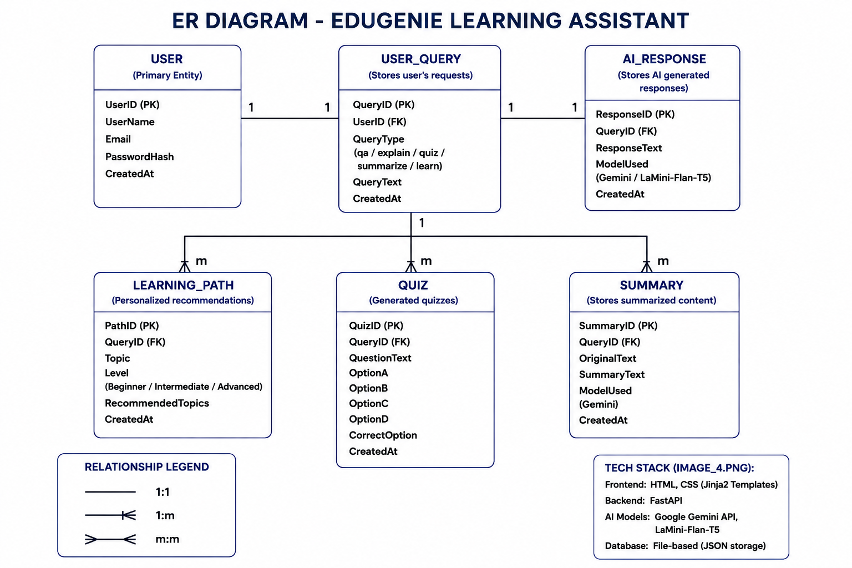
Fig. 3 – ER Diagram: EduGenie Entity-Relationship Model

5.1 Entity Descriptions
USER | UserID (PK), UserName, Email, PasswordHash, CreatedAt
USER_QUERY | QueryID (PK), UserID (FK), QueryType (qa/quiz/summarize/learn), QueryText, CreatedAt
AI_RESPONSE | ResponseID (PK), QueryID (FK), ResponseText, ModelUsed, CreatedAt
QUIZ | QuizID (PK), QueryID (FK), QuestionText, OptionA/B/C/D, CorrectOption, CreatedAt
SUMMARY | SummaryID (PK), QueryID (FK), OriginalText, SummaryText, ModelUsed, CreatedAt
LEARNING_PATH | PathID (PK), QueryID (FK), Topic, Level (Beginner/Intermediate/Advanced), RecommendedTopics, CreatedAt

5.2 Key Relationships
- USER → USER_QUERY: 1:1 (each query belongs to one user)
- USER_QUERY → AI_RESPONSE: 1:1 (each query generates one AI response)
- USER_QUERY → QUIZ: 1:m (one query can generate multiple quiz questions)
- USER_QUERY → SUMMARY: 1:m (one query can produce multiple summaries)
- USER_QUERY → LEARNING_PATH: 1:m (one query maps to multiple learning path entries)

6. PROJECT OBJECTIVES

6.1 Technical Objectives
- Integrate Google Gemini API with a Flask web application
- Handle multimodal input (text, PDF, DOCX, PPTX, images)
- Generate structured MCQ quiz output in JSON format
- Implement streaming responses via SSE for real-time chat
- Support multilingual AI responses

6.2 Performance Objectives
- Efficient prompt construction to minimize token usage
- Fast text extraction from multiple document formats
- Robust error handling and input validation across all endpoints

6.3 Deployment Objectives
- Local development with Flask built-in server
- Production deployment using Waitress WSGI
- Cloud-ready for Render, Railway, AWS EC2, Google Cloud

7. SYSTEM WORKFLOW

- Step 1 – User Interaction: User enters a question, topic, or uploads a document/image via the web interface.
- Step 2 – Input Handling: Flask validates the input. Uploaded files are processed by the appropriate library to extract text.
- Step 3 – Processing Logic: A structured prompt is constructed based on the active feature (Q&A, quiz, summary, chat).
- Step 4 – Gemini API Call: The prompt is sent to the Google Gemini Generative AI API.
- Step 5 – Output Generation: The AI response is cleaned and formatted (JSON for quiz, text for others).
- Step 6 – Response Delivery: Flask returns the JSON response; the frontend renders the result for the user.

8. PREREQUISITES & SETUP

8.1 Software Requirements
- Python 3.10+ • pip • Virtual environment (venv)
- Gemini API Key from Google AI Studio (aistudio.google.com)
- .env file for secure key storage
- Web browser (Chrome / Firefox recommended)

8.2 Setup Commands
python -m venv venv
venv\Scripts\activate # Windows
source venv/bin/activate # macOS / Linux
pip install -r requirements.txt

8.3 Project Structure
EduGenie/
├── app.py # Main Flask application
├── requirements.txt # Project dependencies
├── .env # GEMINI_API_KEY configuration
├── test_api.py # API connectivity test script
├── templates/index.html # Main HTML/Jinja2 template
├── static/ # CSS / JS frontend assets
└── venv/ # Virtual environment

8.4 Configuration (.env)
GEMINI_API_KEY=your_gemini_api_key_here
SECRET_KEY=your_flask_secret_key_here

9. MILESTONE 1: REQUIREMENT ANALYSIS & SYSTEM DESIGN

9.1 Problem Definition
In the current education system, students and teachers frequently deal with large volumes of study material in formats such as PDFs, Word documents, PowerPoint presentations, and images. Extracting key concepts, generating summaries, and preparing assessment questions manually is time-consuming and inefficient. EduGenie addresses this problem by integrating a Flask-based backend with the Gemini Generative AI API to automate educational content understanding and quiz generation through a simple web interface.

9.2 Functional Requirements
The system must allow users to input academic questions and receive AI-generated responses. It must support file uploads in PDF, DOCX, PPTX, and image formats and extract readable text from these files. The application must provide quiz generation that returns structured MCQs in JSON format. The backend must expose REST endpoints (/ask, /quiz, /summary, /chat, /models) and handle all request types. The system must validate user input, handle errors gracefully, and return structured responses.

9.3 Non-Functional Requirements
The system must deliver responses within acceptable time limits given external API latency. API keys must be secured via environment variables. The application must run on standard hardware (4GB RAM minimum) with internet access. The system must be reliable, maintainable, stateless, and production-deployable using Waitress.

9.4 System Design Decisions
EduGenie follows a client-server architecture. Flask was chosen for lightweight REST API implementation. The stateless, database-free design keeps the application focused on AI-driven processing. File-processing libraries (PyPDF2, python-docx, python-pptx, Pillow) handle all supported educational document formats. Waitress was selected over Flask's development server for stable production deployment.

9.5 Technology Stack Justification
Python was selected for its AI/file-processing ecosystem. Flask was chosen for simplicity and REST API suitability. Google Gemini provides state-of-the-art text generation, summarization, and quiz creation. PyPDF2, python-docx, and python-pptx extract academic document text; Pillow handles images. python-dotenv ensures secure API key management.

10. MILESTONE 2: ENVIRONMENT SETUP & INITIAL CONFIGURATION

10.1 Development Environment
The system was developed using Python 3.10, Flask, and Visual Studio Code. A virtual environment isolates project dependencies. An active internet connection is required to access the Gemini API.

10.2 Dependencies (requirements.txt)
- Flask – Web framework
- google-genai – Gemini AI client library
- python-dotenv – Environment variable management
- PyPDF2 – PDF text extraction
- python-docx – DOCX text extraction
- python-pptx – PPTX text extraction
- Pillow – Image handling
- waitress – Production WSGI server
- requests – HTTP communication

10.3 Configuration Setup
The Gemini API key is stored securely in a .env file in the project root and loaded at startup using python-dotenv. The application validates the key presence at initialization and logs an error if missing.

11. MILESTONE 3: CORE SYSTEM DEVELOPMENT

11.1 Feature 1 – AI Question Answering (/ask)
Users submit academic questions via the web interface. Flask validates the input, constructs an educational prompt identifying EduGenie as an expert assistant, and sends it to Gemini. The AI response is returned in the selected language as a JSON object.

11.2 Feature 2 – Quiz Generation (/quiz)
The /quiz endpoint accepts a topic string or extracted file text. A structured prompt requests 5 MCQs in JSON format with question, options A–D, correct answer letter, and explanation. The response is cleaned, JSON-parsed, validated, and returned to the frontend for interactive display.

11.3 Feature 3 – Document Summarization (/summary)
Uploaded files (PDF, DOCX, PPTX, images) are processed using the appropriate library to extract text. The extracted content is sent to Gemini with a summarization prompt in the target language. The generated summary is returned as a text response.

11.4 Feature 4 – Streaming Chat (/chat)
The /chat endpoint uses Flask's stream_with_context and Response with SSE (text/event-stream) to progressively deliver Gemini's response to the browser. Input is validated (max 5000 chars, non-empty). Each response chunk is yielded as a data event.

11.5 Model Auto-Detection
The get_working_model() helper dynamically selects the best Gemini model at startup: priority 1 is gemini-1.5-flash exact match; priority 2 is any 1.5-flash variant; priority 3 is the first available model. This ensures resilience to model deprecations.

12. MILESTONE 4: INTEGRATION & OPTIMIZATION

12.1 Component Integration
All components — frontend forms, Flask routes, file processors, and the Gemini API — were integrated and tested end-to-end. Each endpoint was verified for correct request-response flow, error propagation, and data formatting.

12.2 Performance Optimization
- Input validation before API calls to avoid unnecessary requests
- Efficient prompt construction to minimize token usage
- Text extraction only on file upload (lazy processing)
- Stateless design eliminates database overhead
- Waitress handles concurrent requests reliably in production

12.3 Security Enhancements
- API key secured in .env – never hardcoded in source
- Input length limits (5000 chars for chat)
- File type restrictions for uploads
- No user data stored (stateless, privacy-preserving)
- Flask SECRET_KEY configured via environment variable

12.4 Error Handling
All endpoints use try-except blocks to handle API failures, file processing errors, JSON parsing errors, and invalid inputs. Meaningful error messages are returned as JSON with appropriate HTTP status codes. The system never crashes on expected failure cases.

13. MILESTONE 5: TESTING & VALIDATION

13.1 Test Cases

Test Case ID | Input | Expected Output | Status
TC01 | Valid question to /ask | AI-generated answer in JSON | Passed
TC02 | Topic to /quiz endpoint | 5-MCQ structured JSON returned | Passed
TC03 | PDF uploaded to /summary | Summary text returned | Passed
TC04 | Empty input to /ask | Validation error message (400) | Passed
TC05 | Unsupported file format | File type error message | Passed
TC06 | Message to /chat endpoint | Streaming SSE response delivered | Passed
TC07 | Message > 5000 chars | Length validation error (400) | Passed
TC08 | DOCX uploaded to /summary | Text extracted, summary returned | Passed
TC09 | Telugu language selected | Response in Telugu script | Passed
TC10 | PPTX uploaded to /quiz | Quiz generated from slides | Passed

13.2 Unit Testing
Individual modules tested: input validation, file text extraction (PDF/DOCX/PPTX/image), Gemini API communication, JSON parsing, and model auto-detection. Each function verified independently for valid and invalid inputs.

13.3 Integration Testing
All endpoints (/ask, /quiz, /summary, /chat) tested for complete request-response flow. Frontend forms, Flask routes, file processors, and Gemini API interactions were verified to work together seamlessly.

13.4 Performance Metrics
Average Response Time | 2–5 seconds (Gemini API latency dependent)
Memory Usage | Low – stateless, no DB overhead
Supported File Formats | PDF, DOCX, PPTX, PNG, JPG, JPEG, WEBP, HEIC, HEIF
Max Chat Message Size | 5000 characters
Quiz Output | 5 MCQs with options, answer, explanation
Multilingual Support | Any language supported by Gemini

14. APPLICATION OUTPUTS & SCREENSHOTS

The following screenshots demonstrate EduGenie running live on http://127.0.0.1:5000, showing key features in action:

14.1 Feature: Ask a Question (English)
The user typed 'explain about python' with English selected. EduGenie returned a comprehensive, structured explanation of Python including its characteristics, use cases, and examples.

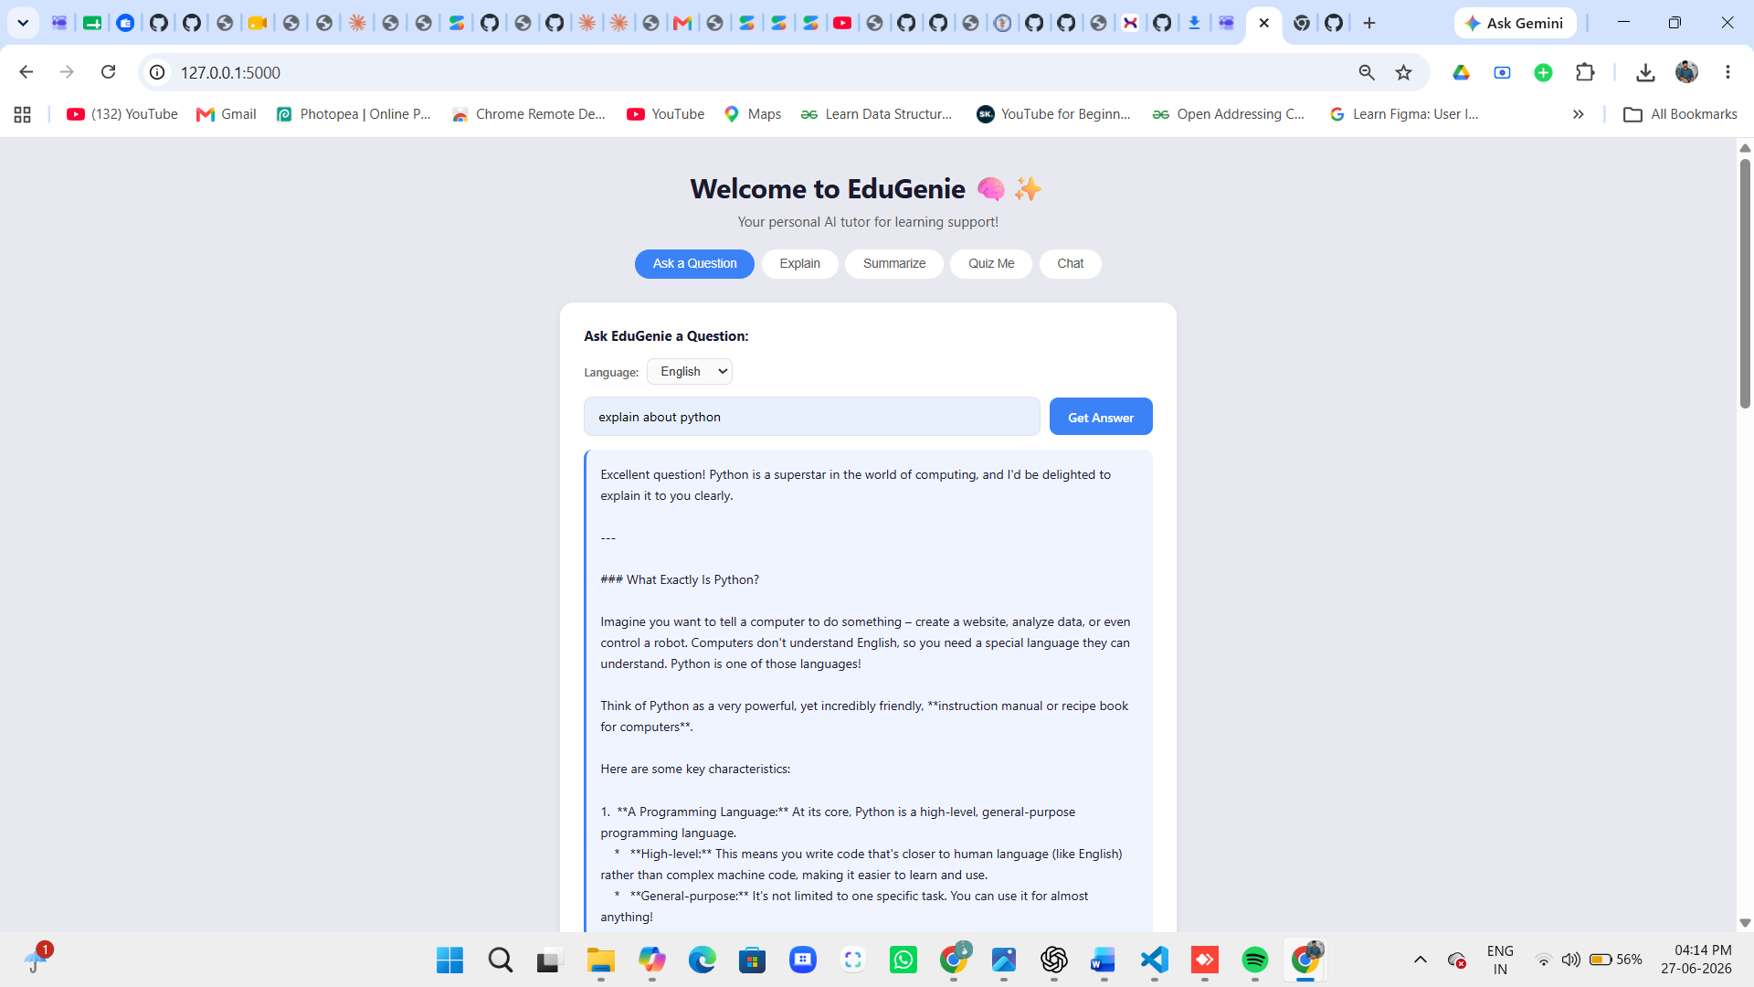
Fig. 4 – Ask a Question: Python explanation in English

14.2 Feature: Ask a Question (Multilingual – Telugu)
The same query 'explain about python' with Telugu language selected. EduGenie returned the full explanation in Telugu script, demonstrating the multilingual support capability powered by the Gemini API.

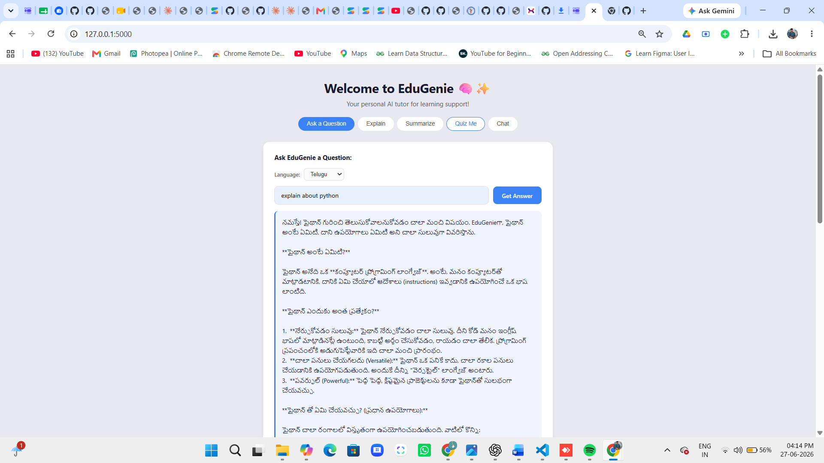
Fig. 5 – Multilingual Support: Python explanation in Telugu

14.3 Feature: Quiz Me (Telugu)
The user entered 'about java' topic and selected Telugu language under the Quiz Me tab. EduGenie generated 5 multiple-choice questions in Telugu about Java programming, with interactive option buttons displayed on the UI.

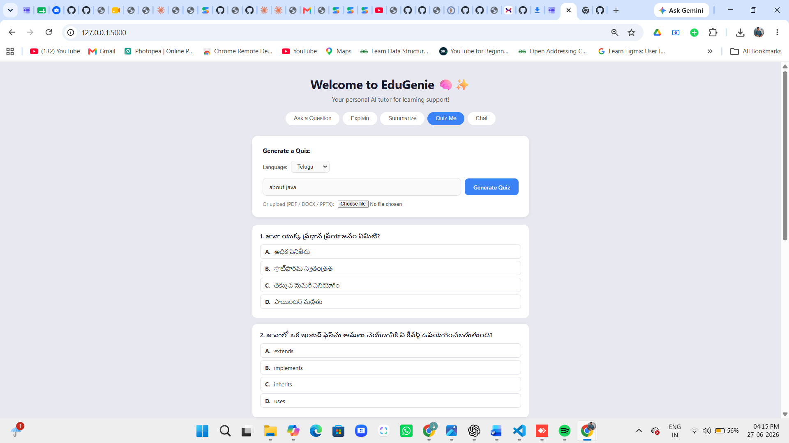
Fig. 6 – Quiz Generation: Java MCQs in Telugu language

14.4 UI Feature Tabs
Ask a Question | Submit any academic question and get an AI explanation
Explain | Get a detailed explanation of a concept
Summarize | Upload a document or paste text for a concise summary
Quiz Me | Generate a 5-question MCQ quiz on any topic or file
Chat | Have a real-time streaming AI conversation

15. DEPLOYMENT

15.1 Deployment Architecture
EduGenie is deployed as a stateless web application. The user's browser sends HTTP requests to the Waitress-served Flask backend. The backend processes requests, communicates with the Gemini API over HTTPS, and returns AI-generated responses.

15.2 Deployment Steps
- Install Python 3.10+ and create virtual environment
- Clone project and navigate to directory
- Install dependencies: pip install -r requirements.txt
- Create .env file with GEMINI_API_KEY
- Run with Waitress:
waitress-serve --host=0.0.0.0 --port=5000 app:app
- Configure cloud platform environment variables and port

15.3 Supported Platforms
- Render • Railway • AWS EC2 • Google Cloud • Heroku • Any VPS with Python

16. RESULTS

EduGenie successfully delivers AI-based answers, structured MCQ quizzes, and document summaries across all tested scenarios. The multilingual feature correctly generates responses in Telugu, Hindi, and other languages. The streaming chat provides a smooth, real-time interaction experience.

System Output | AI answers, quizzes (JSON), summaries – all functional
Multilingual | Verified in English and Telugu (Screenshots in Section 14)
Quiz Generation | 5 MCQs with A/B/C/D options, correct answer, explanation
File Processing | PDF, DOCX, PPTX, image extraction all working
Streaming Chat | Real-time SSE delivery confirmed
Performance | Responsive on 4GB RAM; 2–5 sec API response time

17. ADVANTAGES & LIMITATIONS

17.1 Advantages
- Instant AI-based academic assistance without manual searching
- Supports Q&A, quiz generation, summarization, and streaming chat
- Accepts PDF, DOCX, PPTX, and image file uploads
- Multilingual output – any language supported by Gemini
- Lightweight stateless architecture (no database required)
- Secure API key management via environment variables
- Dynamic model auto-detection for system resilience
- User-friendly five-tab web interface

17.2 Limitations
- Requires stable internet connection (Gemini API dependent)
- Response time varies with external API latency
- No user authentication or session persistence
- Accuracy depends on AI-generated content quality
- Limited scalability without advanced cloud infrastructure
- No conversation memory between sessions

18. FUTURE ENHANCEMENTS

- User authentication and personalized learning dashboards
- Database integration (PostgreSQL/MongoDB) for history storage
- Multi-turn chat memory across sessions
- Multilingual UI with language toggle for the interface itself
- LMS integration (Moodle, Google Classroom)
- Docker containerization and CI/CD pipeline
- Progressive Web App (PWA) for mobile access
- Audio/video input processing
- Analytics dashboard for learning progress tracking

19. CONCLUSION

19.1 Summary
EduGenie was successfully developed as a Flask-based web application integrating the Google Gemini Generative AI API. The system implements AI-based question answering, multilingual responses, quiz generation, document summarization, and streaming chat with support for PDF, DOCX, PPTX, and image inputs. All modules were integrated, tested, and deployed using Waitress.

19.2 Technical Achievements
The project demonstrates successful integration of a Python web framework with a state-of-the-art generative AI service. Key achievements include secure API key management, structured JSON quiz output, multimodal file processing, dynamic model auto-detection, SSE streaming, and multilingual AI responses in production-ready deployment.

19.3 Practical Impact
EduGenie provides instant academic assistance to students and educators, significantly reducing manual effort in preparing notes, quizzes, and summaries. As seen in the screenshots (Section 14), the system successfully generates educational content in both English and regional languages like Telugu, demonstrating real-world utility for diverse learners.

End of Document
EduGenie – Google Gemini Powered Learning Assistant | 2026

